TASK 3 — Responsible AI Report Content
Task 3: Responsible AI & Model Interpretation

Objective
The objective of this task is to understand how machine learning models make decisions and identify important features influencing predictions.

Dataset Used
Titanic Dataset

Tools & Technologies Used
- Python
- Scikit-learn
- Matplotlib
- Google Colab

Libraries Used
- sklearn
- matplotlib

Steps Performed
- Used trained ML model
- Extracted feature importance
- Visualized feature impact
- Analyzed decision-making pattern
- Identified possible bias
- Evaluated fairness of model predictions

Output: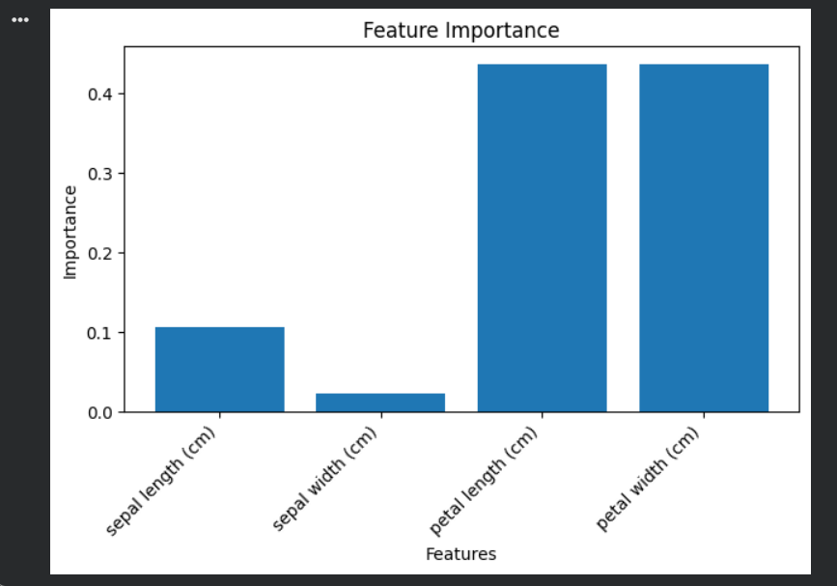

Result
The analysis helped identify the most influential features affecting survival prediction and highlighted possible bias in decision-making.

